Task No 01: Create a class student which contains the basic data about the student that takes the basic student data and displays it by using display method. An option of update is being provided to the user if he/she wants to update the data, the required data being updated.

Code:

Main:

package com.mycompany.lab02task01;

public class Lab02task01 {

    public static void main(String[] args) {

        Student s1 = new Student();

        s1.Input();

        s1.Display();

        s1.Update();

        s1.Display();

    }

}

Student:

package com.mycompany.lab02task01;

import java.util.Scanner;

public class Student {

    static Scanner in = new Scanner(System.in);

    String name, fName, department, email;

    Double gpa;

    char rep;

    public void Input() {

        System.out.println("Enter your Name:");

        name = in.nextLine();

        System.out.println("Enter your Father Name:");

        fName = in.nextLine();

        System.out.println("Enter your Department:");

        department = in.nextLine();

        System.out.println("Enter your Email");

        email = in.nextLine();

        System.out.println("Enter your GPA");

        gpa = in.nextDouble();

    }

    public void Display() {

        System.out.println("  -Your Profile-");

        System.out.println("Name: " + name);

        System.out.println("Father name: " + fName);

        System.out.println("Designation: " + department);

        System.out.println("Email: " + email);

        System.out.println("GPA: " + gpa);

    }

    public void Update() {

        System.out.println("\nDo you want to update your Data?");

        System.out.println("Reply y for Yes, n for No.....");

        rep = in.next().charAt(0);

        if (rep == 'y' || rep == 'Y') {

            Input();

        } else if (rep == 'n' || rep == 'N') {

            System.out.println("Have a nice day");

        } else {

            System.out.println("Invalid Input! Please reply with y or n.....");

        }

    }

}

Output:

Task No 02: Create a class “computer” which contains specifications of computer, the program shall ask the user does he/she wants to open the system, if the user press “yes” then the system starts shows the initial loading and then displays the basic configuration of a system (by calling the method of display () , update option is being provided by the user, values of the specified items are being updated once user decides to update that item.

Code:

Main:

package lab02task02;

import java.util.Scanner;

public class Lab02task02 {

    public static void main(String[] args) {

        Scanner in = new Scanner(System.in);

        Computer c1 = new Computer();

        char rep;

        System.out.println("Do you want to open the system?");

        System.out.println("Press y or yes n for no....");

        rep = in.next().charAt(0);

        if (rep == 'y' || rep == 'Y') {

            System.out.println("Loading.......................100%\nprocessing data...............100%\nfinalizing....................100%");

            c1.Display();

            c1.Update();

            c1.Display();

        } else if (rep == 'n' || rep == 'N') {

            System.out.println(" ");

        } else {

            System.out.println("Invalid Input! Please press y or yes n for no....");

        }

    }

}

Computer:

package lab02task02;

import java.util.Scanner;

public class Computer {

    static Scanner in = new Scanner(System.in);

    String ram = "8 GB";

    String storage = "500 GB";

    String processor = "Core i5";

    String gen = "6th";

    String oS = "Wingows 10 Pro 64 bit";

    char rep;

    public void Display() {

        System.out.println("\n  -System Specifications-");

        System.out.println("Processor: " + processor);

        System.out.println("Generation: " + gen);

        System.out.println("RAM: " + ram);

        System.out.println("Storage: " + storage);

        System.out.println("Operating System: " + oS);

    }

    public void Update() {

        System.out.println("\nDo you want to update any Feature?");

        System.out.println("Reply y for Yes, n for No.....");

        rep = in.next().charAt(0);

        if (rep == 'y' || rep == 'Y') {

            System.out.println("Which of the following do you want to update?");

            System.out.println("a) Processor\nb) Generation\nc) RAM\nd) Storage\ne) Operating System");

            System.out.println("Please reply from a to e.......");

            rep = in.next().charAt(0);

            switch (rep) {

                case 'a', 'A':

                    System.out.print("Enter the Processor: ");

                    processor = in.nextLine();

                    break;

                case 'b', 'B':

                    System.out.print("Enter the Generation: ");

                    gen = in.next();

                    break;

                case 'c', 'C':

                    System.out.print("Enter the RAM: ");

                    ram = in.nextLine();

                    break;

                case 'd', 'D':

                    System.out.print("Enter the Storage: ");

                    storage = in.nextLine();

                    break;

                case 'e', 'E':

                    System.out.print("Enter the Operating System: ");

                    oS = in.nextLine();

                    break;

                default:

                    System.out.println("Invalid Input! Please reply from a to e.......");

                    break;

            }

        } else if (rep == 'n' || rep == 'N') {

            System.out.println("Have a nice Day");

        } else {

            System.out.println("Invalid Input! Please reply from a to e.......");

        }

    }

}

Output:

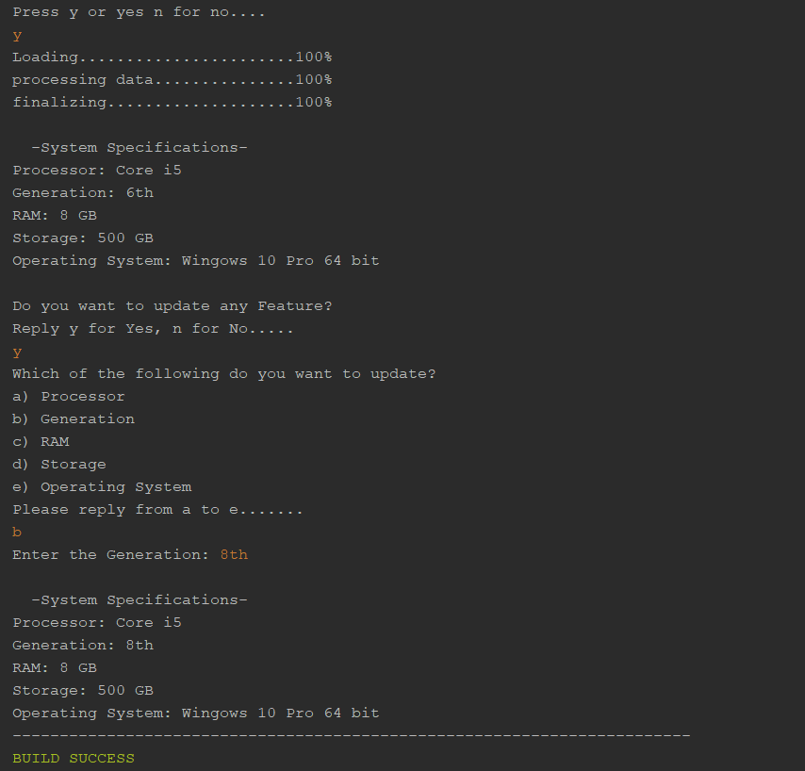

Task No 03: Create a class of Employee which contains basic information about an employee, employee name, father’s name and salary etc. are being displayed by the display method and the salary of employees or the designation of the employees are being set/updated as per need.

Code:

Main:

package lab02task03;

public class Lab02task03 {

    public static void main(String[] args) {

    Employee e1 = new Employee();

    e1.input();

    e1.Display();

    e1.Update();

    e1.Display();

    }

}

Employee:

package lab02task03;

import java.util.Scanner;

public class Employee {

    static Scanner in = new Scanner(System.in);

    String name, fName, designation;

    int age, salary;

    char rep;

    public void input() {

        System.out.println("Enter your Name:");

        name = in.nextLine();

        System.out.println("Enter your Father Name:");

        fName = in.nextLine();

        System.out.println("Enter your Designation:");

        designation = in.nextLine();

        System.out.println("Enter your Age");

        age = in.nextInt();

        System.out.println("Enter your Salary");

        salary = in.nextInt();

    }

    public void Display() {

        System.out.println("\n  -Your Profile-");

        System.out.println("Name: " + name);

        System.out.println("Father name: " + fName);

        System.out.println("Designation: " + designation);

        System.out.println("Age: " + age);

        System.out.println("Salary: " + salary);

    }

    public void Update() {

        System.out.println("\nDo you want to update any Data?");

        System.out.println("Reply y for Yes, n for No.....");

        rep = in.next().charAt(0);

        if (rep == 'y' || rep == 'Y') {

            System.out.println("Which of the following do you want to update?");

            System.out.println("1) Designation\n2) Salary");

            System.out.println("Reply with 1 or 2........");

            int resp = in.nextInt();

            switch (resp) {

                case 1:

                    System.out.println("Enter your Designation:");

                    designation = in.nextLine();

                    break;

                case 2:

                    System.out.println("Enter your Salary");

                    salary = in.nextInt();

                    break;

                default:

                    System.out.println("\nInvalid Input! Please reply with 1 or 2........");

                    break;

            }

        } else if (rep == 'n' || rep == 'N') {

            System.out.println("\nHave a nice day....");

        } else {

            System.out.println("\nInvalid Input! Please reply with y or n........");

        }

    }

}

Output:

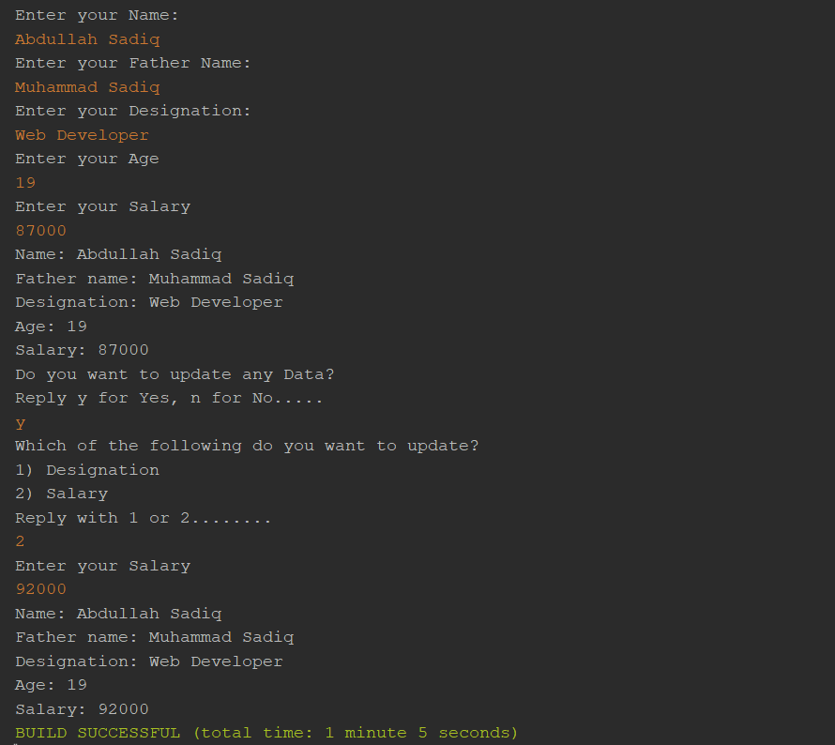

Task No 04: Create a class of Automobile which contains specifications of a car, check whether the car is in - ON/start state if not them asks the user if he/she want to start the car, If the car is already in start state then first display the current status of the car which includes the horse power, color, made, engine type etc. providing an option to the user if he/she wants to update any of the mentioned part from the car, if user selects “YES” then it is updated according to the need of the user, else the program will be ended.

Code:

Main:

package lab02task04;

public class Lab02task04 {

    public static void main(String[] args) {

        AutoMobile e1 = new AutoMobile();

        e1.Input();

        e1.Display();

    }

}

AutoMobile:

package lab02task04;

import java.util.Scanner;

public class AutoMobile {

    static Scanner in = new Scanner(System.in);

    int horsePower = 1400;

    String color = "Red";

    String engineType = "Electrical";

    String transmission = "Mannual";

    char rep;

    public void Input() {

        System.out.println("Car is ON or OFF?");

        System.out.println("Reply 1 for ON and 2 for OFF......");

        rep = in.next().charAt(0);

        if (rep == '1') {

            Display();

            Update();

        } else if (rep == '2') {

            System.out.println("Do you want to start the car?");

            System.out.println("Reply y for yes n for no......?");

            rep = in.next().charAt(0);

            if (rep == 'y' || rep == 'Y') {

                Display();

                Update();

            } else if (rep == 'n' || rep == 'N') {

                System.out.println("Have a nice day");

            } else {

                System.out.println("Invalid Input! Please reply with y or n......");

            }

        } else {

            System.out.println("Invalid Input! Please reply with 1 0r 2......");

        }

    }

    public void Display() {

        System.out.println("  -Current Status-");

        System.out.println("Engine Type: " + engineType);

        System.out.println("Horse Power: " + horsePower);

        System.out.println("Transmission: " + transmission);

        System.out.println("Color: " + color);

    }

    public void Update() {

        System.out.println("\nDo you want to update any feature?");

        System.out.println("Reply y for yes n for no......?");

        rep = in.next().charAt(0);

        if (rep == 'y' || rep == 'Y') {

            System.out.println("Which part do you want to update?");

            System.out.println("1) Color\n2) Engine\n3) Transmission\n4) Engine Horse Power");

            System.out.println("Reply between 1 to 4......");

            rep = in.next().charAt(0);

            switch (rep) {

                case '1':

                    System.out.print("Enter the color: ");

                    color = in.next();

                    break;

                case '2':

                    System.out.print("Enter the Engine Type: ");

                    engineType = in.next();

                    break;

                case '3':

                    System.out.print("Enter the Transmission: ");

                    transmission = in.next();

                    break;

                case '4':

                    System.out.print("Enter the Horse Power: ");

                    horsePower = in.nextInt();

                    break;

                default:

                    System.out.print("Invalid Input! Please reply between 1 to 4......");

                    break;

            }

        } else if (rep == 'n' || rep == 'N') {

            System.out.println("Have a nice day");

        } else {

            System.out.println("Invalid Input! Please reply with y or n......");

        }

    }

}

Output:

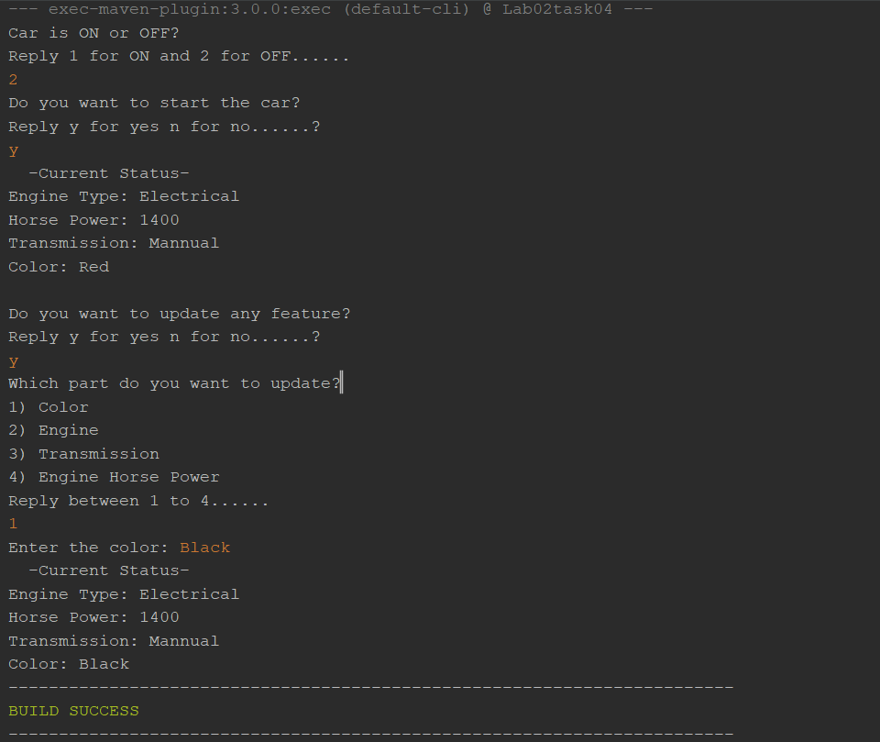

Task No 05: Implement a class Car, that has the characteristics Brandname, PriceNew (which represents the price of the car when it was new), Color and Odometer (which is milo meter shows number of milage travelled by car).

The class should have:

1. A method getPriceAfterUse() which should return the price of the car after being used according to the following formula:

Car price after being used=priceNew\*(1-(odometer/600,00))

1. A method updateMilage (double travelled distance) that changes the current state of the car by increasing its milage.
2. A method outputDetails() that will output to the screen all the information of the car, i.e. brandname, priceNew, priceused, color and odometer.

Code:

Main:

package lab02task05;

public class Lab02task05 {

    public static void main(String[] args) {

        Car c1 = new Car();

        c1.input();

        c1.getPriceAfterUse();

        c1.updateMilage();

        c1.Output();

    }

}

Car:

package lab02task05;

import java.util.Scanner;

public class Car {

    static Scanner in = new Scanner(System.in);

    String brandName, color;

    double priceNew, priceUsed, odoMeter, milage;

    public void input() {

        System.out.println("Enter the brand of the car: ");

        brandName = in.nextLine();

        System.out.println("Enter the color: ");

        color = in.nextLine();

        System.out.println("Enter the Price when it was new: ");

        priceNew = in.nextDouble();

        System.out.println("Enter the distance trevelled by the car: ");

        odoMeter = in.nextDouble();

    }

    public void getPriceAfterUse() {

        double a, b;

        a = odoMeter / 60000;

        b = 1 - a;

        priceUsed = priceNew \* b;

    }

    public void updateMilage() {

        milage = odoMeter \* 2;

    }

    public void Output() {

        System.out.println("\nBrand name: " + brandName);

        System.out.println("Color: " + color);

        System.out.println("Actual price: " + priceNew);

        System.out.println("Price after use: " + priceUsed);

        System.out.println("Odometer Reading: " + milage);

    }

}

Output:

